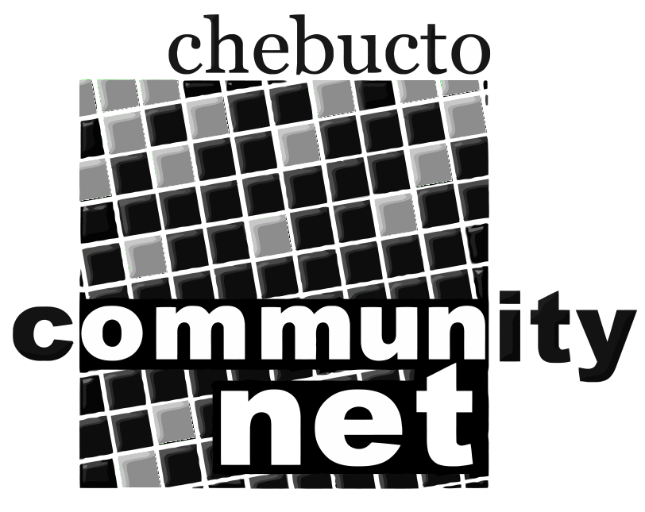 | Chebucto Community Net  Annual General Meeting  April 14, 2016
Agenda
6:30 - 7:00 PM Social Meet and Greet old friends and new. Refreshments
provided.

Call to Order

Video: "Digging To The Future!"
1. Minutes of the 2015 Annual General Meeting
2. Report from the Chair
3. Treasurer's Report
4. Policy Committee Report
5. Technical Report
6. Election of Directors
7. Appointment of Auditor
8. Other business
9. Awarding of door prizes to winning members in attendance
10. Adjournment
All are welcome to attend this meeting. However, only members in good standing are eligible to vote on the motions presented or be nominated for office. Proxy voting is not permitted.

